Paper Title

A. Author*, C. Coauthor** and S. Secondcoauthor*
* Name of Institution/Department, City, Country
** Name of Institution/Department, City, Country
e-mail addresses of all authors

Abstract. Instructions for papers preparation for conference CD proceedings.
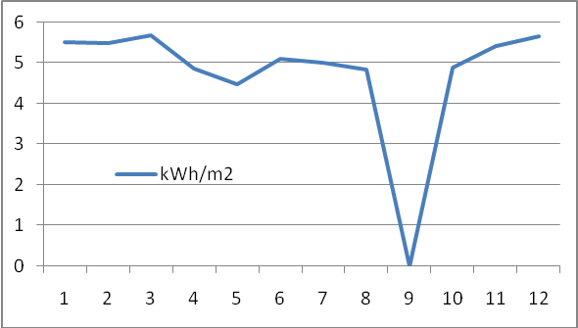
- Diagram of electrical energy consumption efficiency in 2011. Note how the caption is centered in the column
Key words. Energy, efficiency, consumption

INTRODUCTION
Please prepare your paper in accordance to presented template. Submit papers by sending an e-mial addressed on an adequate conference event email address.

First Subtitle
Prepare your paper in full-size format, on A4 paper (210 x 297 mm). Number of pages is not limited.

Type sizes and typefaces: Follow the type sizes specified in Table 1. Times New Roman is the preferred font.

Margins: top and bottom = 25mm, left and right = 20 mm.

The column width is 82mm (3.23 in). The space between the two columns is 6mm (0.24 in).

Left- and right-justify your columns. Use tables and figures to adjust column length. On the last page of your paper, adjust the lengths of the columns so that they are equal. Use automatic hyphenation and check spelling.

In a paper title, capitalize the first word and all other words except for conjunctions, prepositions less than seven letters, and prepositional phrases.

FURTHER INSTRUCTIONS

Figures and Tables
Position figures and tables at the tops and bottoms of columns. Avoid placing them in the middle of columns. Large figures and tables may span across both columns. Figure captions should be centered below the figures; table captions should be centered above. Avoid placing figures and tables before their first mention in the text.

References
Number citations consecutively in square brackets [1]. Refer to the reference number, as in Ref. [3].

Number footnotes in superscripts. Place the actual footnote at the bottom of the column in which it was cited. Do not put footnotes in the reference list.
TABLE 1.
Type Sizes for Papers
Type size (pts.) | Appearance
Type size (pts.) | Regular | Bold | Italic
7 | Table captions, table superscripts in uppercase
9 | References, tables, table names, first letters in table captions, figure captions, footnotes, text subscripts, and superscripts
10 | Authors’ affiliations, equations | Abstract Key words
11 | Main text |  | Subheading
11 | Authors’ names
24 | Paper title

Papers that have not been published, even if they have been submitted for publication, should be cited as “unpublished” Ref. [4]. Papers that have been accepted for publication should be cited as “in press” Ref. [5].

For papers published in translated journals, first give the English citation, then the original foreign-language citation Ref. [6].

Abbreviations and Acronyms
Define abbreviations and acronyms the first time they are used in the text, even after they have been defined in the abstract. Do not use abbreviations in the title unless they are unavoidable.

Equations
Number equations consecutively with equation numbers in parentheses flush with the right margin, as in (1). Punctuate equations with commas or periods when they are part of a sentence, as in
$a + b = c$. (1)
Use “(1)” to refer to the equation.

ACKNOWLEDGEMENT
Put sponsor acknowledgments in the unnumbered footnote on the first page. Do not number Acknowledgement and References, and begin Subheadings as numbered list (example 1.1).

REFERENCES
- L. Perez-Lombard, J. Ortiz, and C. Pout, “A review on buildings energy consumption information”, Energy and buildings, vol. 40, Issue 3, Elsevier, 2008, pp. 394–398.
- D. Fiaschi, R. Bandinelli, and S. Conti, “A case study for energy issues of public buildings and utilities in a small municipality: Investigation of possible improvements and integration with renewables”, Applied Energy, vol. 97. Elsevier, 2012, pp.101–114.
- K. Wild, “Title of paper if known,” unpublished.
- R. Jakovljev, “Title of paper with only first word capitalized”, Journal Name and Abbreviation, in press.
- S. Bosnjak, J. Birovljev, A. Polic, K. Bogataj, Z. Bosnjak, and O. Grljevic “Energy management information system for energy supply management and optimization“, (Energetski upravljački informacioni sistem u menadžmentu i optimizaciji snabdevanja energijom), 17th International Scientific Conference “Strategic Management and Decision Support Systems in Strategic Management”, Serbia, 2012, pp. 23-24, ISBN: 978-86-7233-30406.

